Workshop: Petstagram
This document contains the fourth part of the Petstagram Workshop. Today, we will add a user to our project. First, we will start by extending the user model. Then, we will implement the register, login, and logout functionalities. We will work with the profile templates. We will also refactor the code in all apps to add the user object where it is needed.
The full project description can be found in the Workshop Description Document.

Workshop - Part 4.1

Extending the User Model
There are several ways that we can choose from to implement our user model. The way Django handles authorization is a perfect fit for our project but still, we want to add extra attributes without having to create a separate Model. So, we are going to create a custom user model inheriting from the AbstractUser Django class.
- The first and last names of each user should have a minimum length of 2, and a maximum length of 30. Also, they must contain only alphabetical letters.
- Each registered email in the app must be unique.
- The gender is a choice field where the user can choose between "Male", "Female" and "Do not show" options:
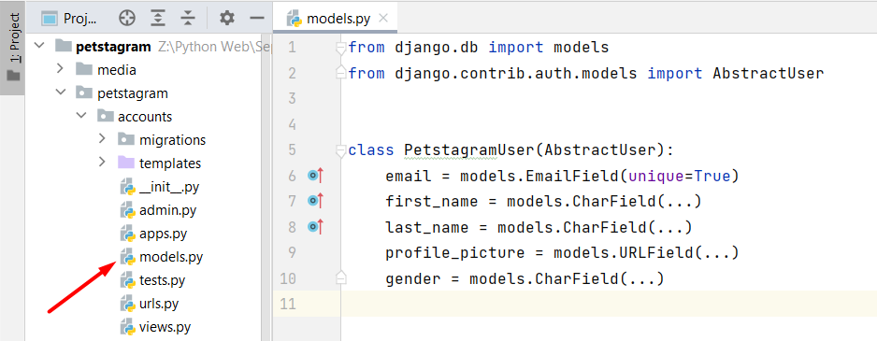
Then, we will need to update the settings.py defining the AUTH_USER_MODEL property to our custom user model: 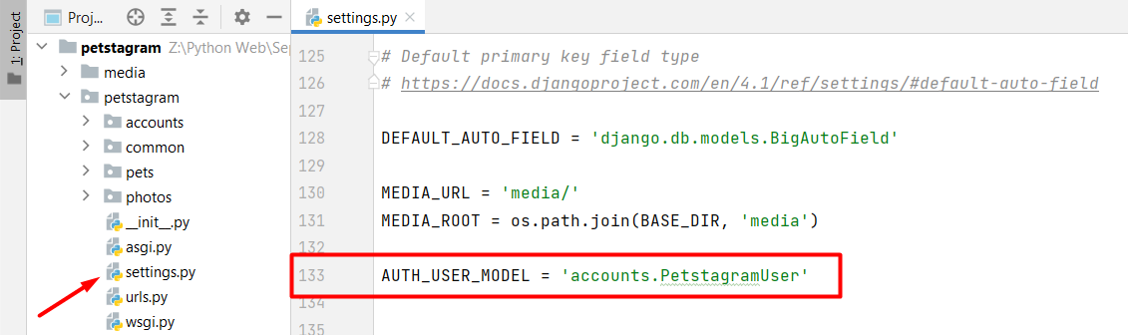
Note: if you are building an app with user authentication, you should consider creating a custom user model at the beginning of the work process.
As this is a workshop project, for the needs of this course, we will need to drop the database and create it all over again. Then, we can delete all migration files, and make the migration for all apps once again.
Next, we will register the created model in the administration, and we can test if the implementation works correctly.

Adding User Registration
To create a user registration form, we can extend the Django built-in UserCreationForm. Let us add a forms.py file in our accounts app and inherit from the built-in Django form: 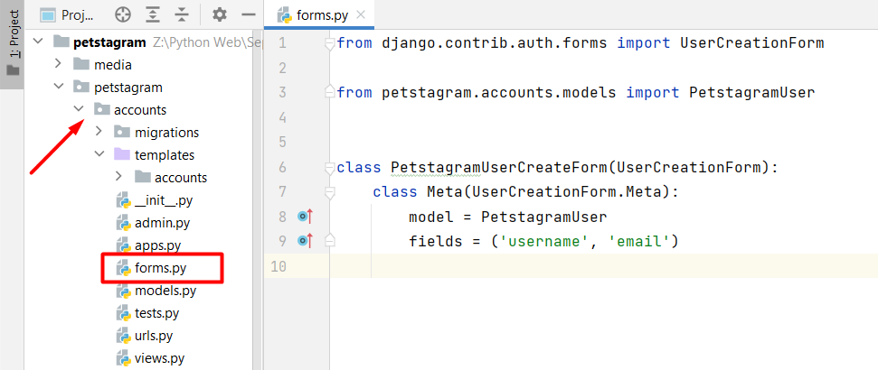
Let us now add the form functionality in the register view (when the user is successfully registered, they should be redirected to the login page). As we know more about the CBVs in Django we will try to implement the register functionality using CreateView. There we should add the model, the form, the template, and the success URL: 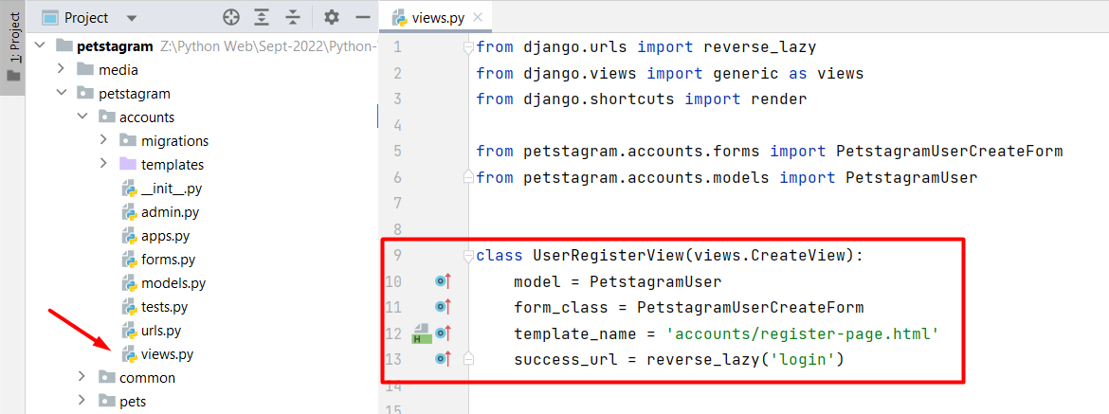
We should change the view in the path function on accounts/urls.py file: 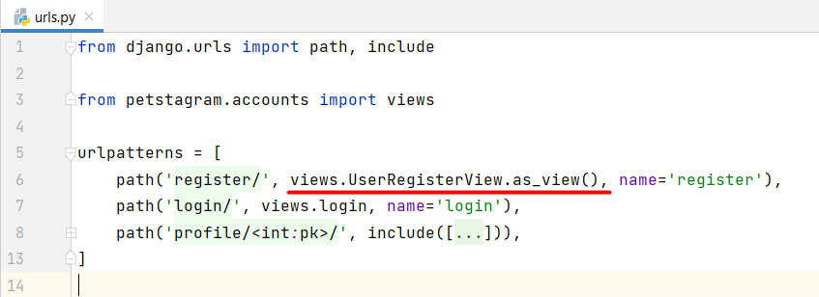
Next, we will add the form to the register-page.html template. We can escape showing the help texts on the web page, by simply adding the concrete fields we want our users to fill. Note: Do not forget to add a "href" on the Login link: 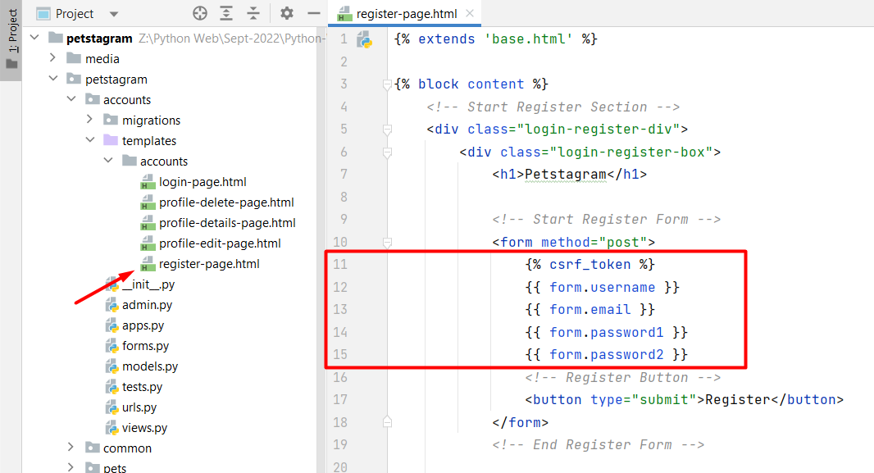
However, it is not enough - it is missing the placeholders: 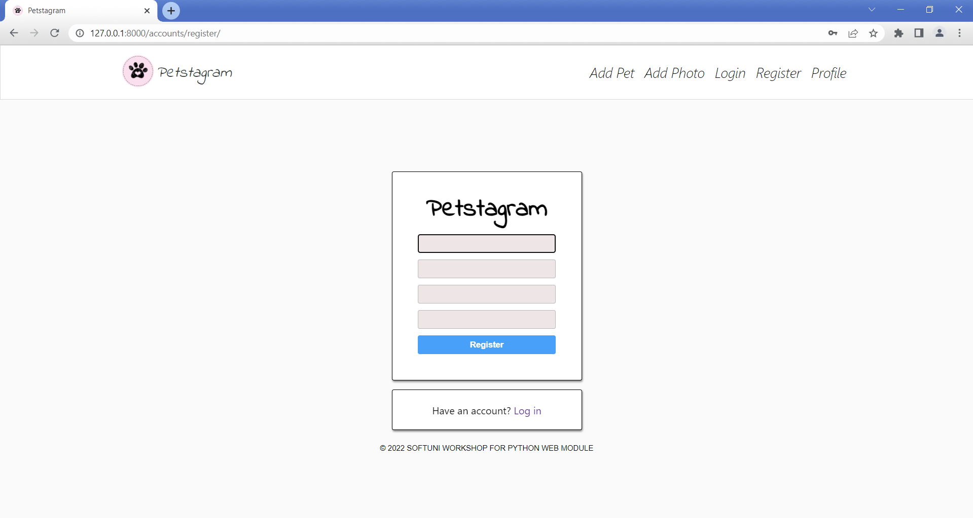
To add them, we can easily create a template filter. Add a templatetags package in the accounts app and create a custom_filters.py file. Then, add the implementation of the placeholder and register it: 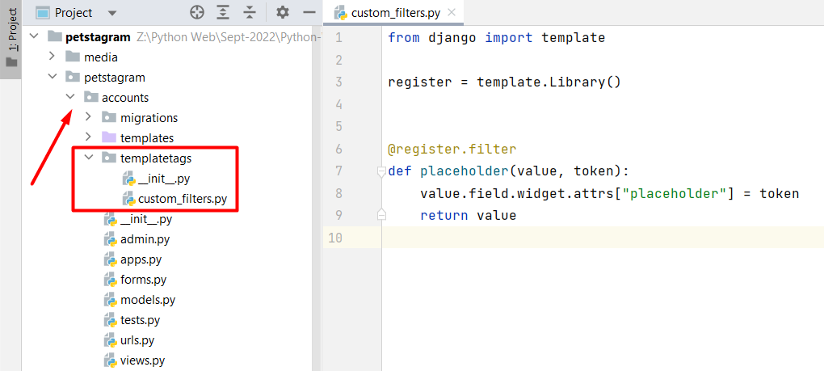
Now, we can add the template filter with the value we want to show on the page: 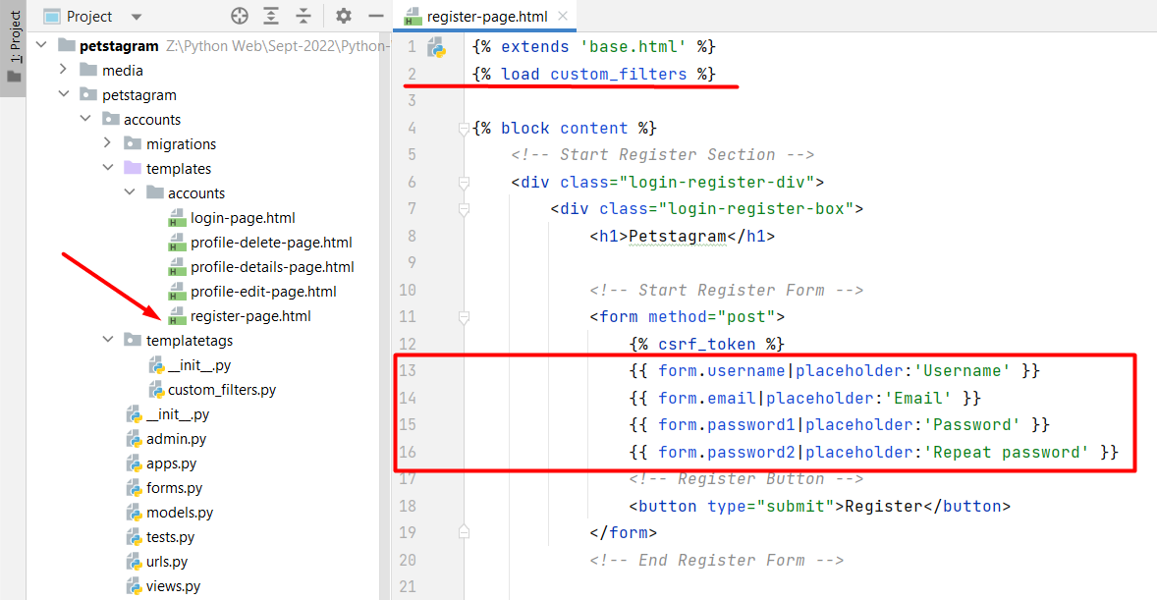
Also, we want to show errors when they accur. We can decide if they are going to stay above or below the field: 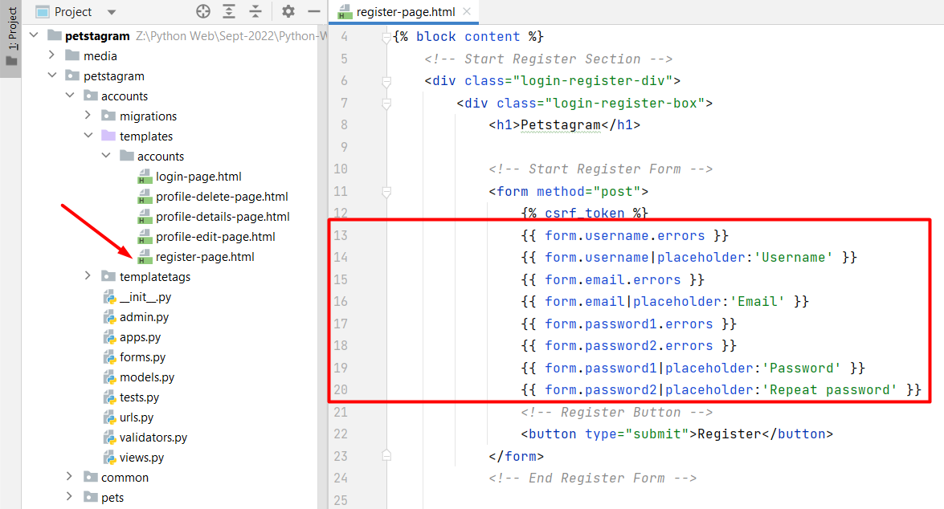
Restart the development server and check if the implementation works correctly: 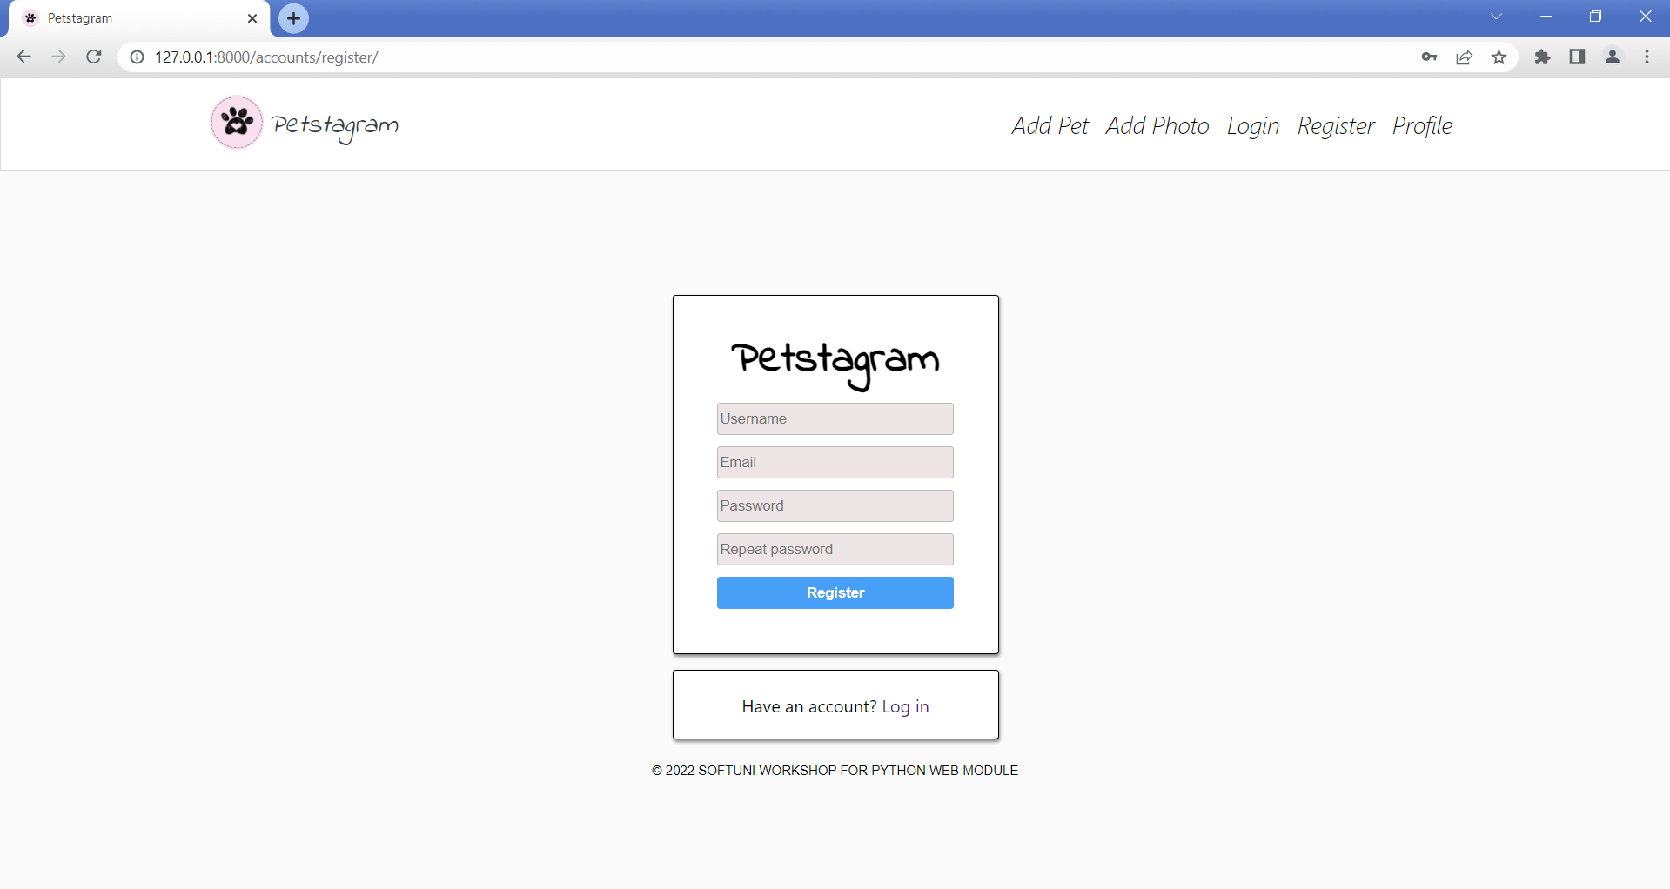

Adding User Login
Now, it is time to add a user login functionality. First, we will override the AuthenticationForm so that we can add placeholders in the fields "username" and "password":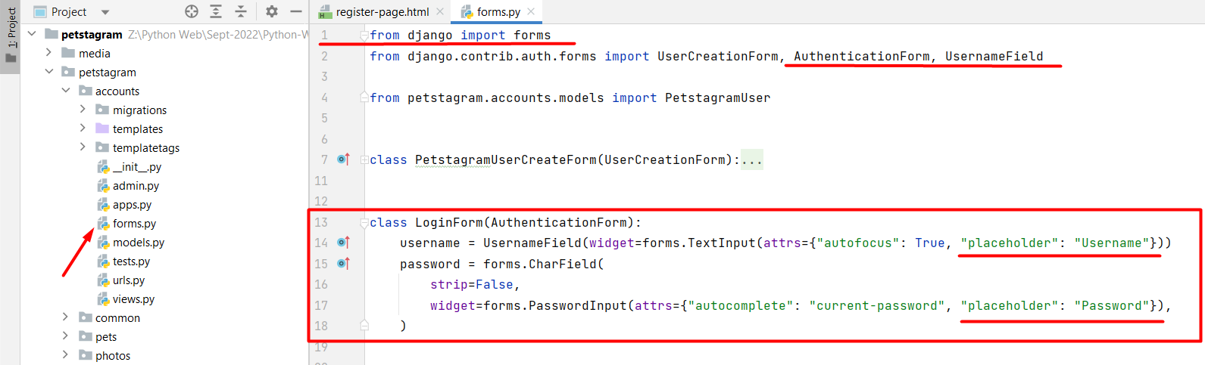
We can use the built-in view LoginView from the contrib.auth.views module. We will add the overridden form, the template we want to use, and the URL where requests are redirected after login: 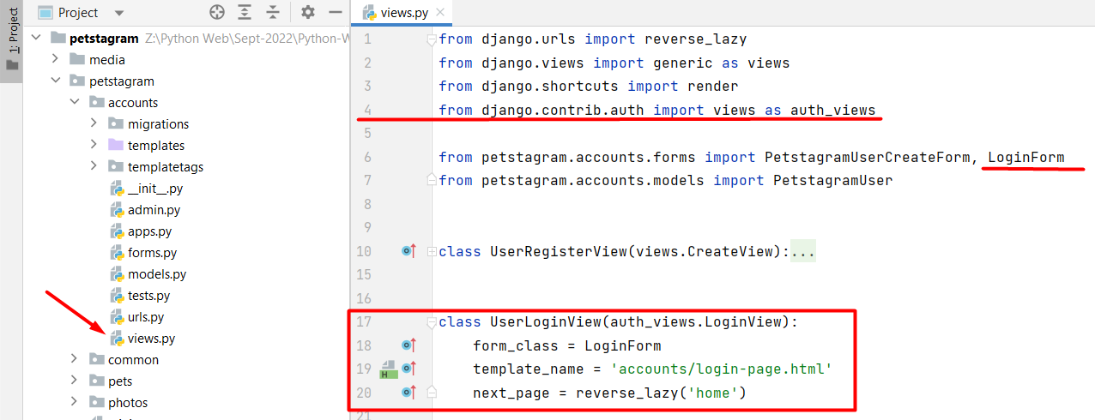
Let us refactor the login-page.html template by adding the "form" attribute. Note: Do not forget to add the "href" on the Register link. Then, start the development server and check if the form is created correctly.

Adding User Logout
Let us create the user logout functionality. First, we will add the path in the account/urls.py file: 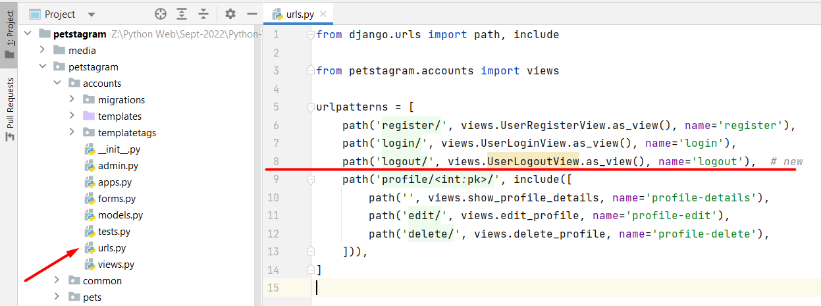
Next, we will use the Django built-in LogoutView to reuse the logout functionality implementation and only will overwrite the next_page attribute, so it redirects to the login page after the user successfully logs out: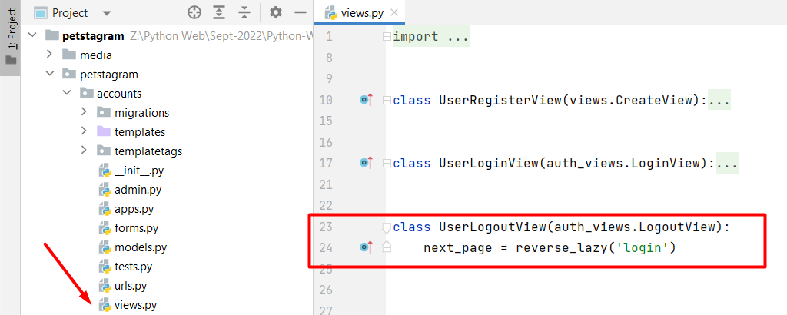
Last, we will add a button that the users will use to log out from the app. Let us open the base.html file and use a HTML code to implement a new navigation bar hyperlink: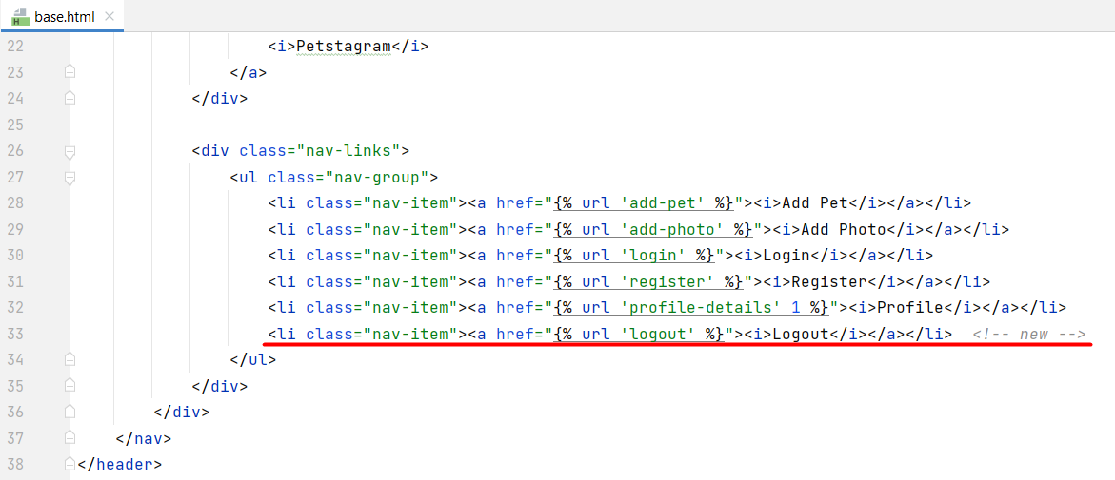
Start the development server and check if the implementation works correctly.

Workshop - Part 4.2

Add User Editing
We will continue to implement the user functionality by adding a user edit form. We want the form to contain the username, first name, last name, email, profile picture, and gender: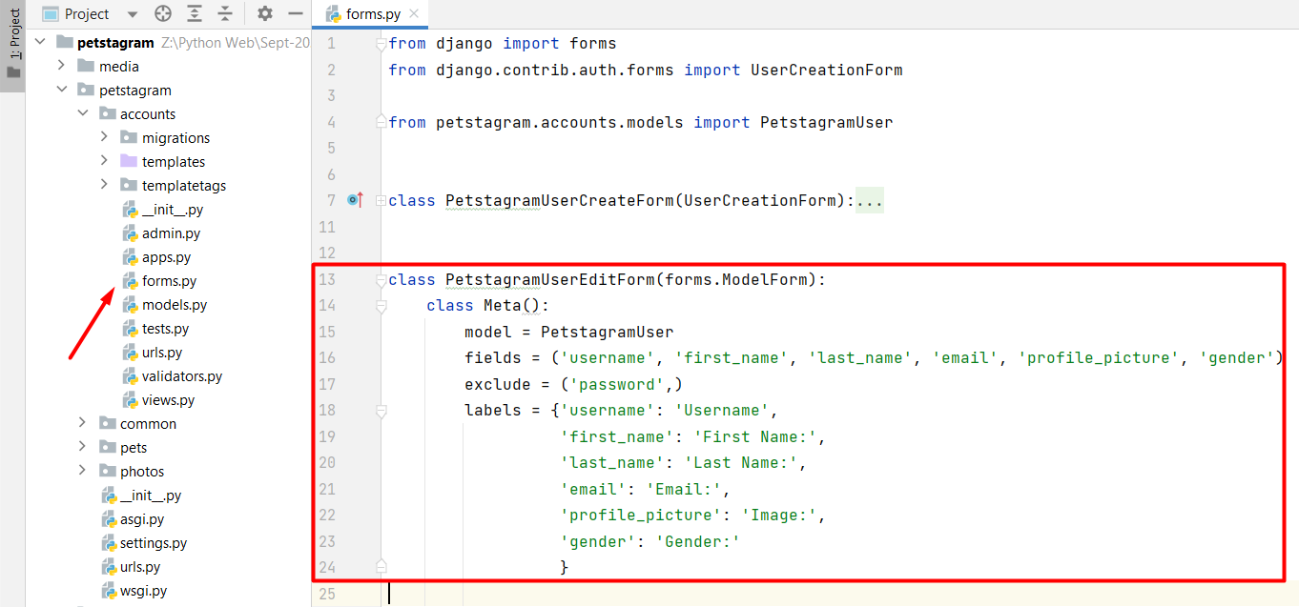
Then, we will implement the profile edit view that will inherit from the UpdateView class: 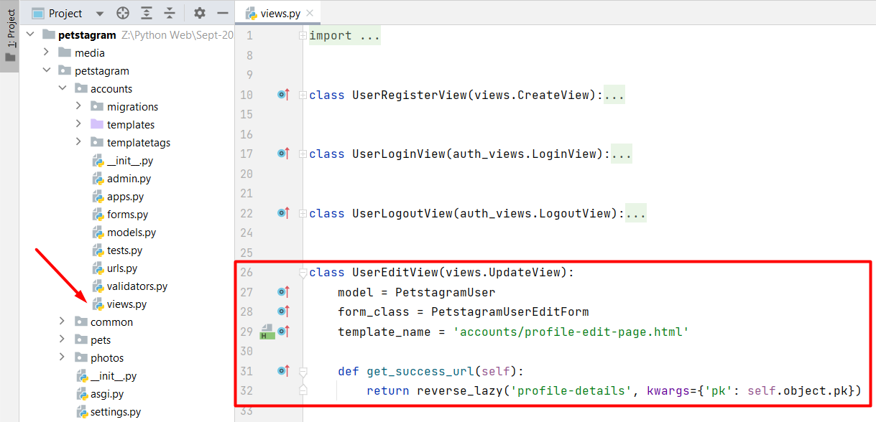
Next, we will refactor the code in the profile-edit-page.html template to implement the user form using the Django template language:
{% extends 'base.html' %}
{% block content %}
<!-- Start Edit Profile Section -->
<div class="edit-delete">
<h2>Edit Profile</h2>
<!-- Start Edit Profile From -->
<form method="post">
{% csrf_token %}
{% for field in form %}
<p class="error"> {{ field.errors }} </p>
<div class="label-input">
<label>{{ field.label }}</label>
{% if not field.label == "Gender:" %}
{{ field }}
{% else %}
<div class="list-choice">
<div class="list-choice-title">Gender</div>
<div class="list-choice-objects">
{% for type, value in form.fields.gender.choices %}
<label>
<input type="radio" value="{{ value }}" name="gender"
{% if form.gender.value == value %}
checked
{% endif %}/>
<span>{{ value }}</span>
</label>
{% endfor %}
</div>
</div>
{% endif %}
</div>
<br>
{% endfor %}
<!-- Edit Profile Button -->
<button class="edit-btn" type="submit">Edit</button>
</form>
<!-- End Edit Profile Form -->
</div>
<!-- End Edit Profile Section -->
{% endblock %}

Workshop - Part 4.3

Refactor Navigation Bar
Now, as we have a user, we need to make some changes to the app. Let us start by refactoring the navigation bar. We want to show the links "Profile" and "Logout" to authenticated users only, and the links "Register" and "Login" to unauthenticated users only. Open the base.html template and add the condition: 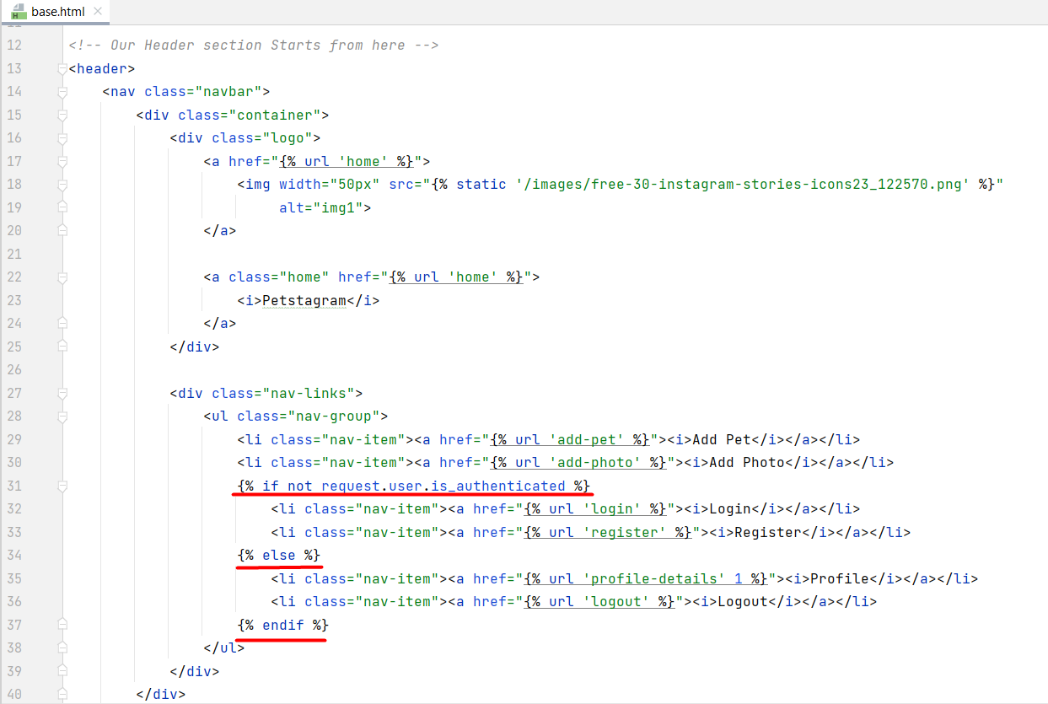
Next, we can implement the Profile Page URL: 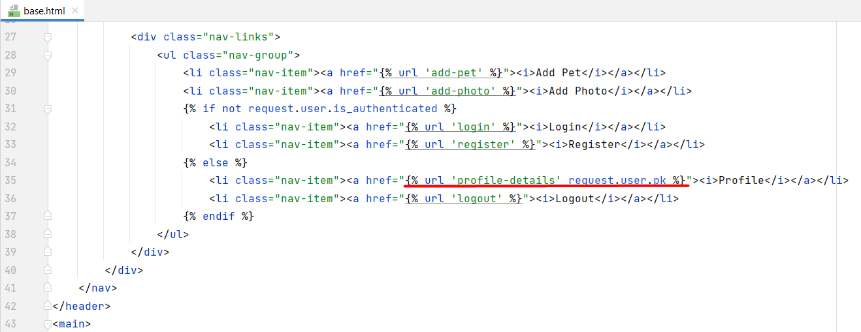

Refactor Models
We should connect the project models to the user. Let us start by adding the user to the pet's model: 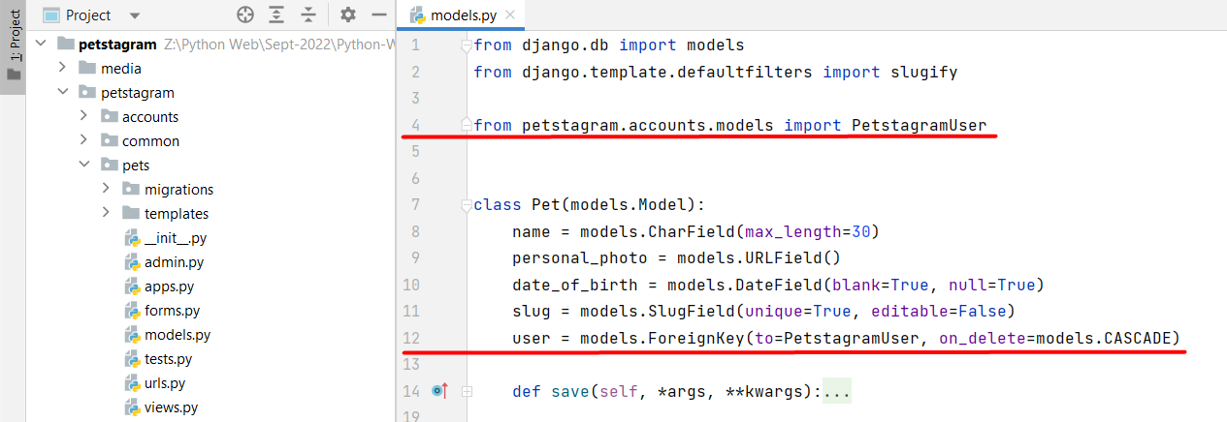
Next, we can connect the user to the photos, the comments, and the likes. Make the migration files and migrate the changes to the database.
When a user creates a pet or a photo they should be automatically added to the model. Let us implement it: 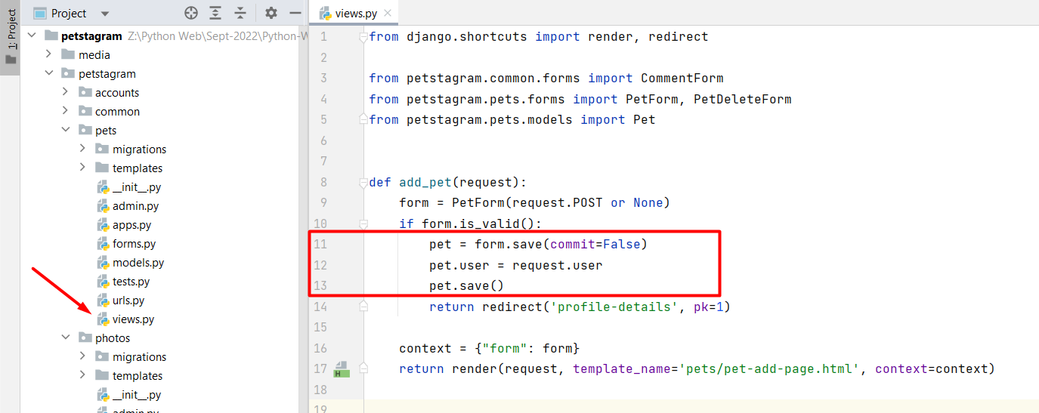
Implement the functionality to the add_photo view, too. Note: when our form includes many-to-many fields, we should also call form.save_m2m() after saving the model instance. Make changes to the forms if needed.
We should also add the user to the like and comment views. Let us start by refactoring the code in the like_functionality view: 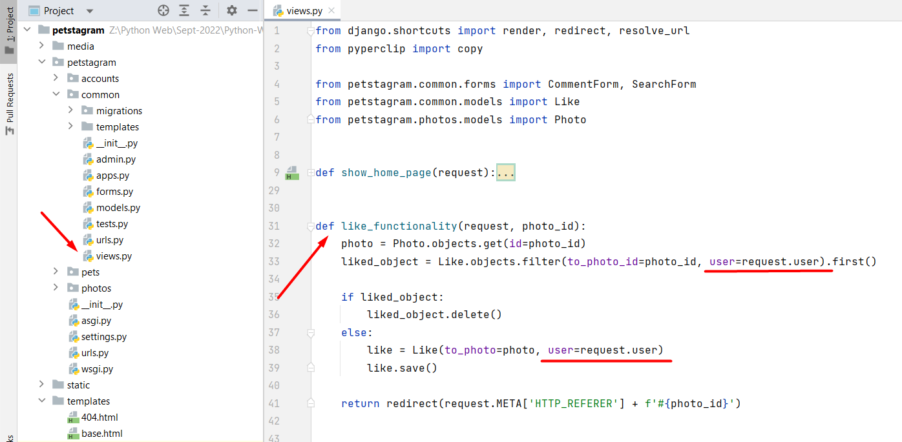
Next, add the user to the comment they post: 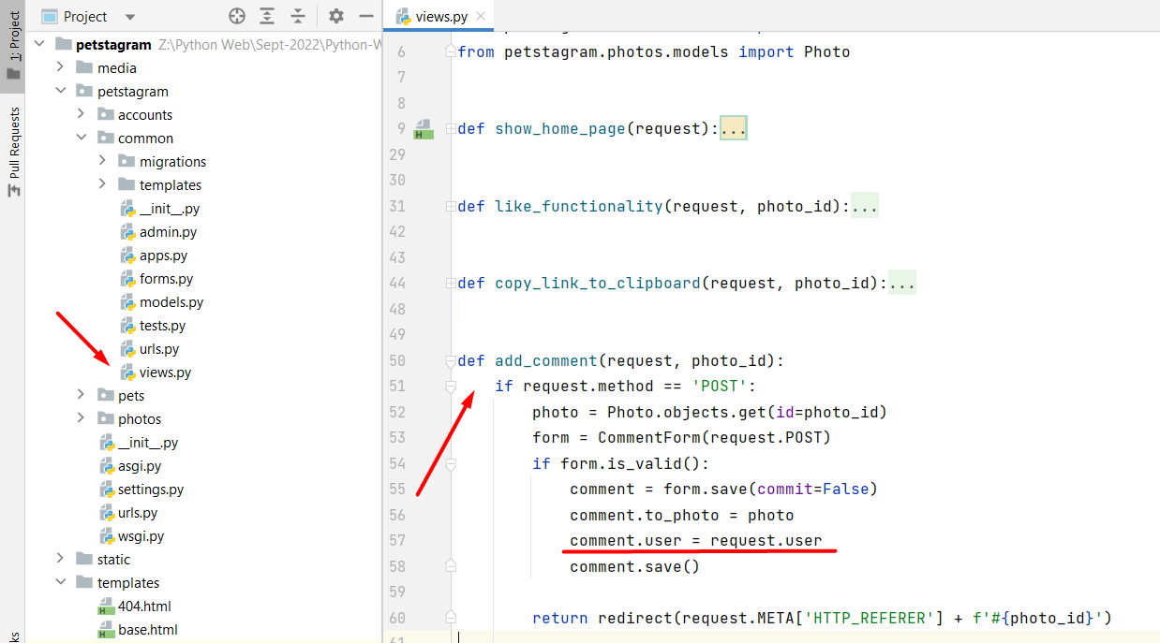

Refactor Pet Photo Posts
Let us now work to improve the interface of the home page. First, we should check the show_home_page view. We will need to add sorting for the likes made by the current user using the app, so the app shows the user which photos are liked by them: 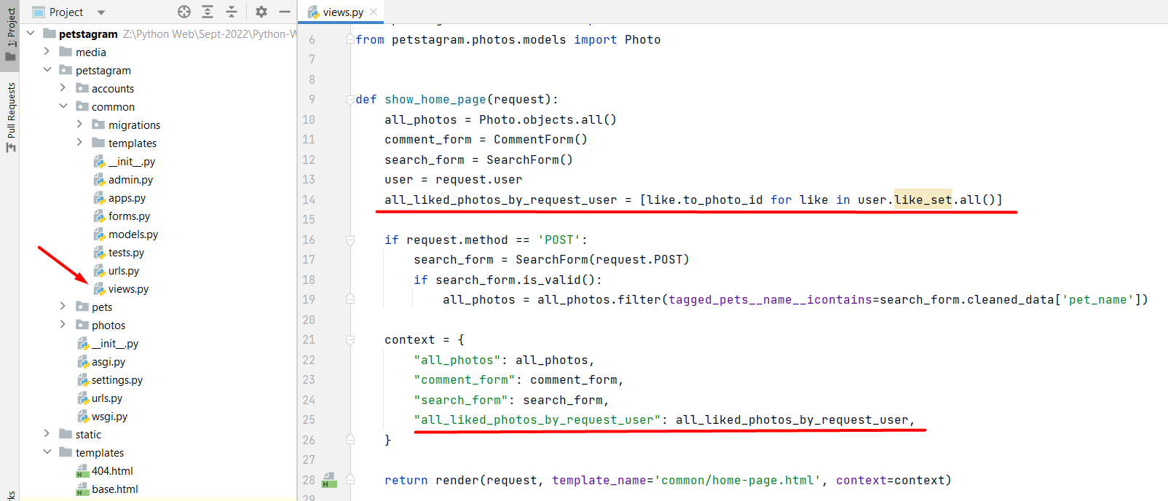
Now, we are ready to refactor the pets-posts.html template. We want for each picture to show to the user who uploaded it. Let us open the file and start implementing the user information: 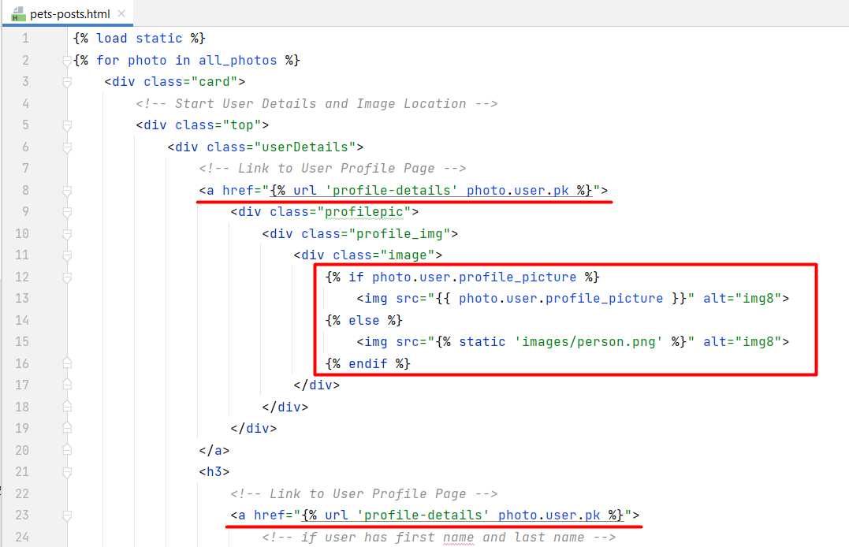
On the next rows we can see that we should show the first and/or the last name of the user if they exist. Otherwise, we should show the user's username. To do that, we can escape writing code in the template by adding an additional method to the user model: 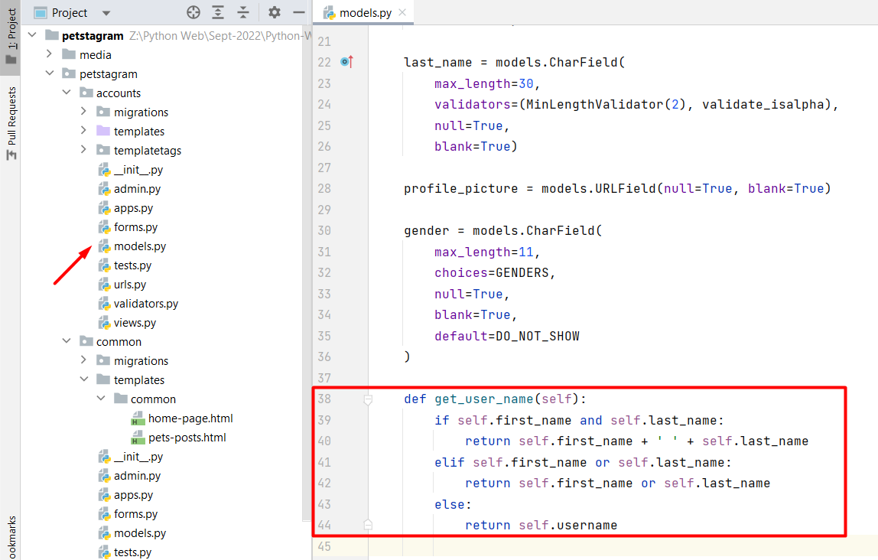
Then, we can use the method in the template: 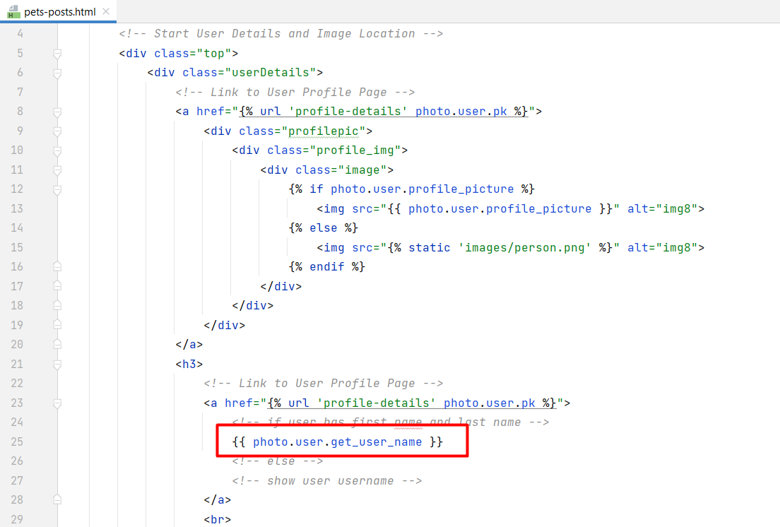
We will change the visualtion of the like button, so it shows which pictures are liked by the user: 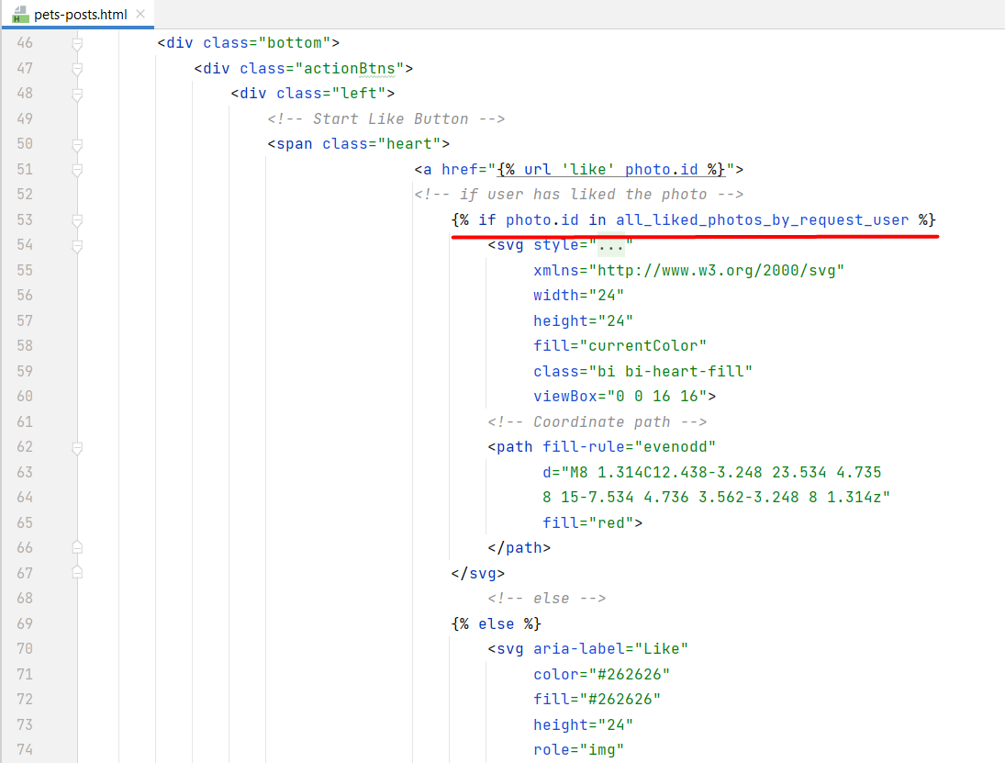
We should refactor the pet details URL, too: 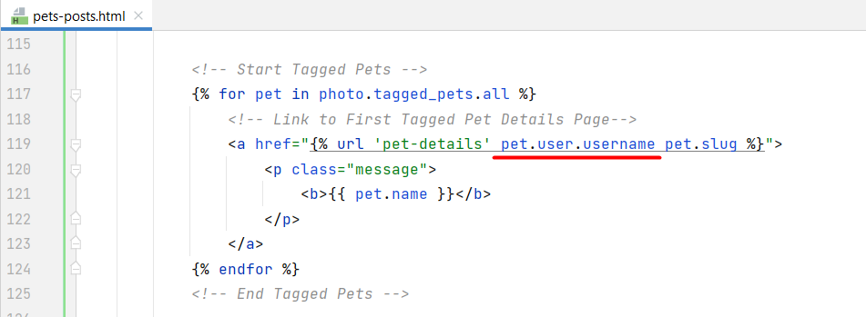
Start the development server and check the visualization.

Refactor Photo Details Page
Add the photo owner's data, and the comment user data and implement the like button visualization, so the current user see if they liked the photo or not. The buttons edit and delete should be only visible to the owner of the photo. Hint: you can check if the user liked the photo by filtering them in the likes set: 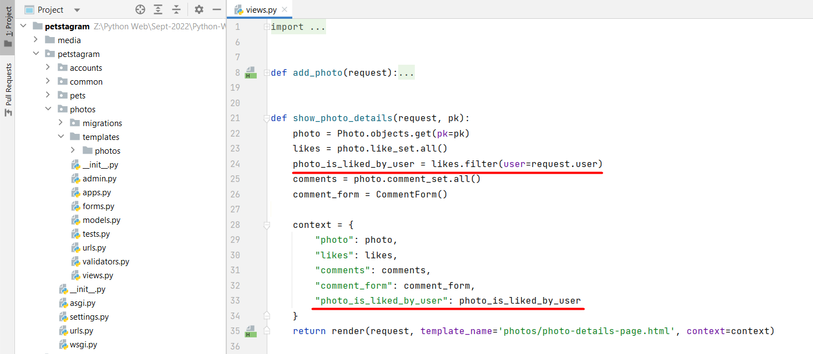

Refactor Profile Details Page
It is time to add the user data to the profile. We will use a CBV to generate the user model, and the template and we will additionally add the total count of likes in the context: 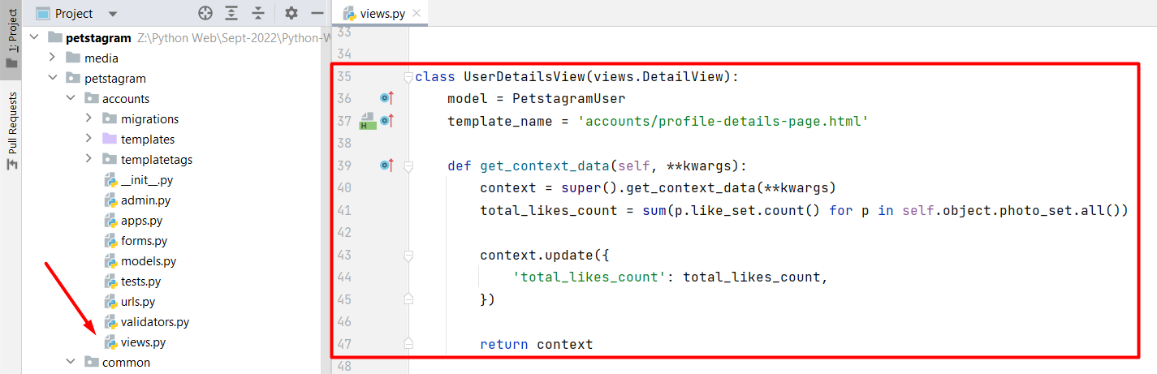
In the profile-details-page.html template we will add the user data, the count of all user photos, the count of all user pets, and the count of all likes that the user has collected, all user pets, and all user photos.

Check for Additional Changes
Do not forget to check all functionality on the app to see if everything works correctly:
- Check if the user object is needed elsewhere.
- Check all links and buttons.
- Login is required for all pages and buttons, except for the home page, and share post button.
Example: in the pet app, the show_pet_details view should find the owner of the pet and use it to visualize the edit/delete button to the owner of the pet only: 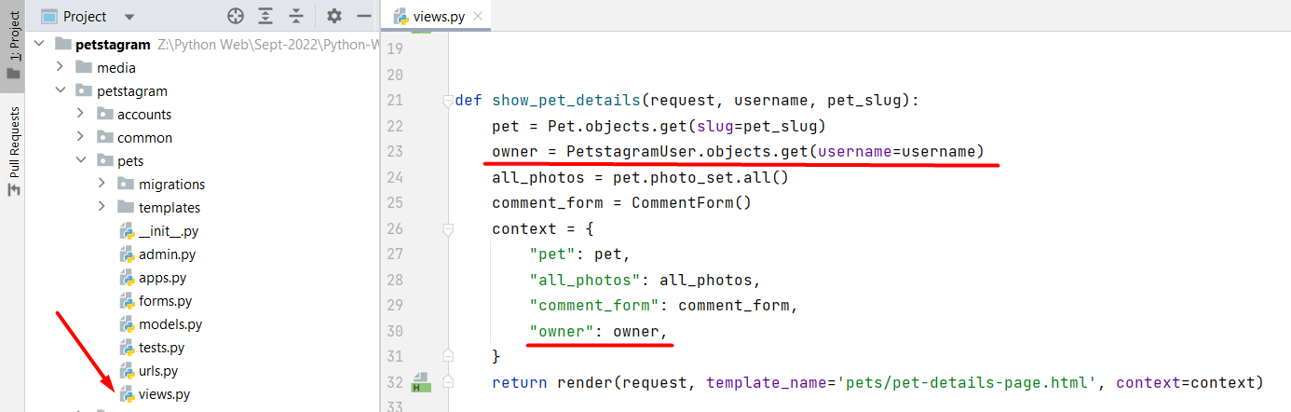
Add the implementation of the URL in the pet-details-page.html template, too: 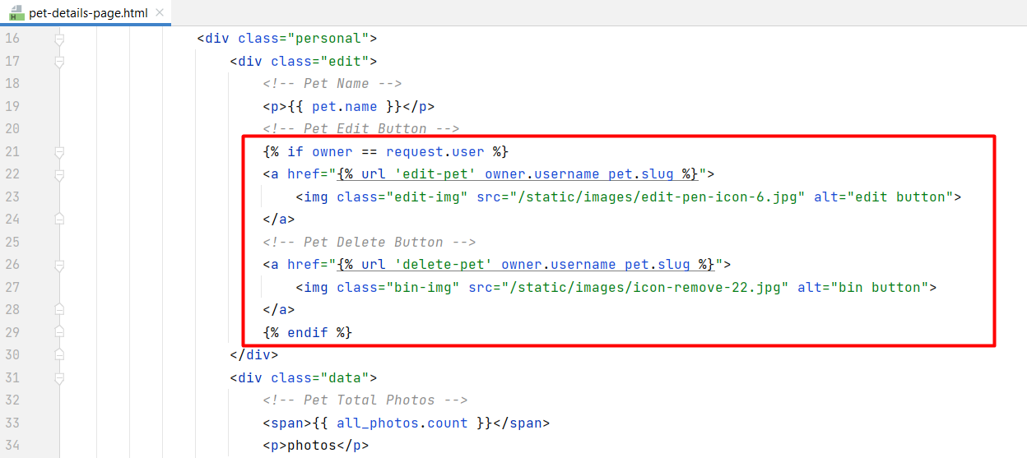

Workshop - Part 4.4

Add user delete functionality
We will add the final user functionality for this workshop. When a user is deleted, all their photos, pets, likes, and comments should be deleted too. Then, the app redirects to the home page with no authentication: 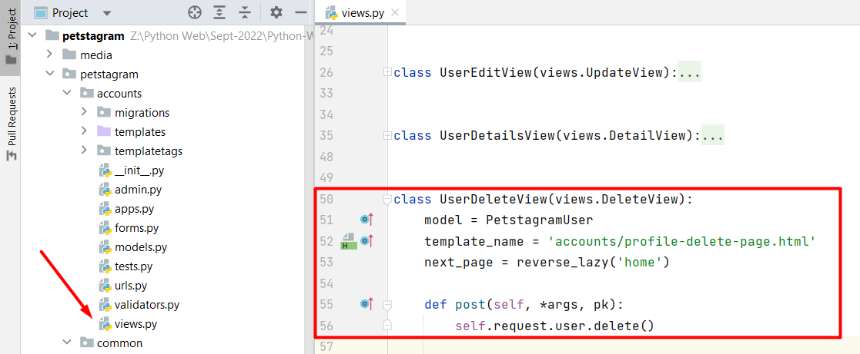
We should refactor the profile-delete-page.html template: 